Install xdebug with laravel in vscode ubuntu 22.04 with different version of php
#laravel #ubuntu #xdebug

Different php version has different xdebug.
follow xdebug installtion step according to php version setuped in your machine
php -v
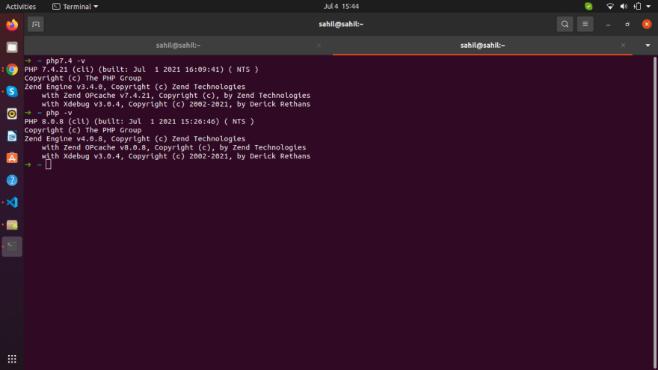
this will return the php version, if xdebug is configured it will show , if not let's install it
let's install xdebug
sudo apt install php-xdebug

php --ini
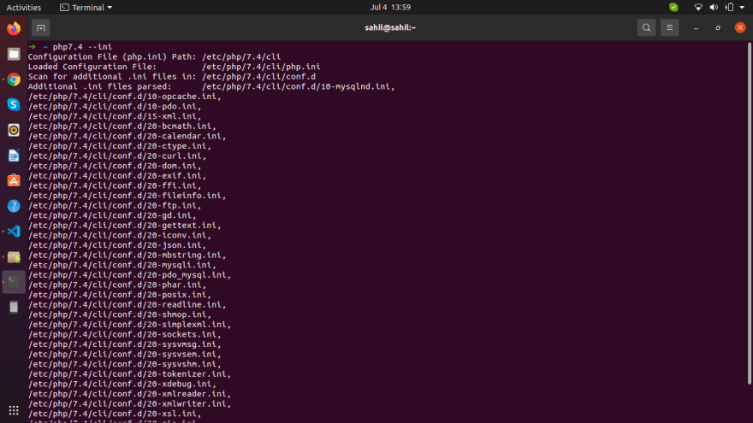
look for
/etc/php/8.1/mods-available/xdebug.ini
and add this to /etc/php/8.1/mods-available/xdebug.ini
; zend_extension=xdebug.so
zend_extension=/usr/lib/php/20210902/xdebug.so
xdebug.mode = debug
xdebug.start_with_request = yes
xdebug.client_port = 9003
xdebug.log_level = 0

now type in

php -v
you should see xdebug string returned in output

Note if you are confused about which php version is needed for which xdebug

to check which xdebug.so files are available use locate, if locate not availbe use this cmd to install it
sudo apt install mlocate
locate xdebug.so
simply paste the details you recieved from

php -i
here https://xdebug.org/wizard
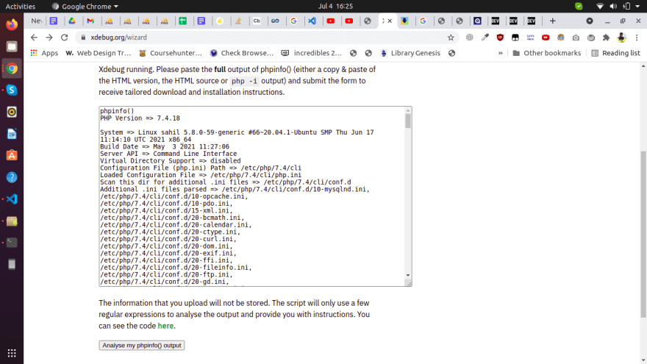

now go to vscode
Install PHP Debug extension
by Felix Becker
now open the laravel project in vscode
ctrl+shift+D
for opening debug config
generate the launch.json
save the file launch.json with this code

{
// Use IntelliSense to learn about possible attributes.
// Hover to view descriptions of existing attributes.
// For more information, visit: https://go.microsoft.com/fwlink/?linkid=830387
"version": "0.2.0",
"configurations": [
{
"name": "Listen for Xdebug",
"type": "php",
"request": "launch",
"port": 9003
},
{
"name": "Launch currently open script",
"type": "php",
"request": "launch",
"program": "${file}",
"cwd": "${fileDirname}",
"port": 0,
"runtimeArgs": [
"-dxdebug.start_with_request=yes"
],
"env": {
"XDEBUG_MODE": "debug,develop",
"XDEBUG_CONFIG": "client_port=${port}"
}
},
{
"name": "Launch Built-in web server",
"type": "php",
"request": "launch",
"runtimeArgs": [
// "-dxdebug.mode=debug",
// "-dxdebug.start_with_request=yes",
"-S",
"localhost:8000",
"-t",
"public"
],
"program": "",
"cwd": "${workspaceRoot}",
"port": 9003,
"serverReadyAction": {
"pattern": "Development Server \\(http://localhost:([0-9]+)\\) started",
"uriFormat": "http://localhost:%s",
"action": "openExternally"
}
},
{
"name": "php8.1Launch Built-in web server",
"type": "php",
"request": "launch",
"runtimeExecutable": "php8.1",
"runtimeArgs": [
// "-dxdebug.mode=debug",
// "-dxdebug.start_with_request=yes",
"-S",
"localhost:8000",
"-t",
"public"
],
"program": "",
"cwd": "${workspaceRoot}",
"port": 9003,
"serverReadyAction": {
"pattern": "Development Server \\(http://localhost:([0-9]+)\\) started",
"uriFormat": "http://localhost:%s",
"action": "openExternally"
}
}
]
}

get the debugging started with xdebug on vscode
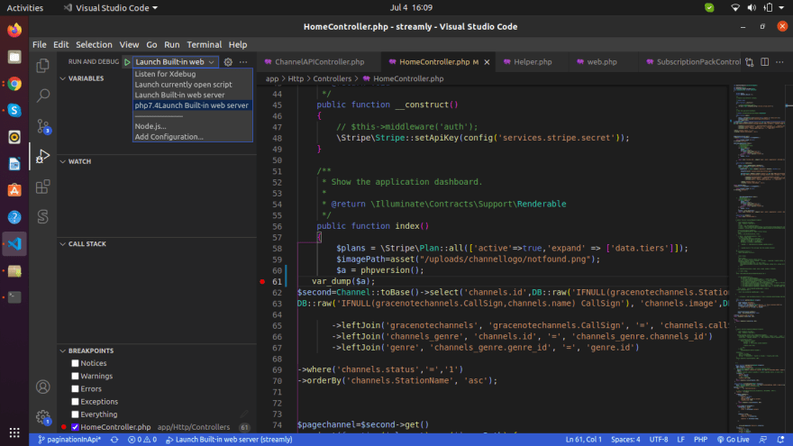
click on green play button your out will look something like this
